1. Create a HOC that add random colour to the background of 2 component.

* Creating 2 Components to make it into a rectangle box using App.css

App.js

Output:

* Before Refresh

* After refresh

1. Advance task (use lodash.js)
2. symmetric difference of 2 arrays

Lodash1.js (ignore the error as there are two

console log for two different output)

Output XOR

Output XOR 2

1. symmetric difference of 2 arrays

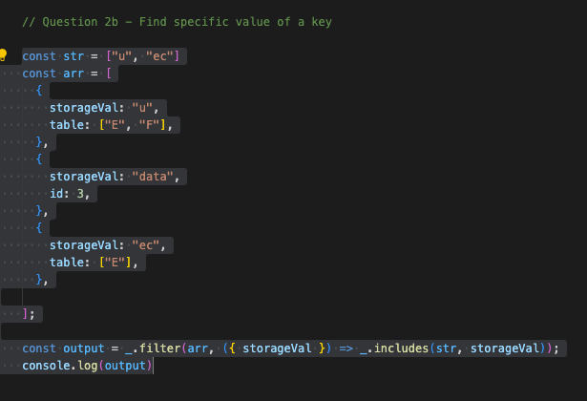

Output:

1. Flatter array

Output:

1. Also, Flatten Array

Output:

1. Complete the Task using Hooks
2. Create an array of objects and update its second index

Hooks.JS

Output:

Before clicking on Update State Button:

After clicking on Update State Button:

1. Create an object, update its 2 property values

Output:

Before clicking on the Update Profile Button

After clicking on the Update Profile Button

Overall App.js of the assignment:

1. Create a form using Functional Components. Add validation. (Controlled Input)

Creating Form using Functional Components

App.js

Output

If the Form is empty and submits button is pressed

If the username is invalid

If the email is invalid

If the password is invalid

If all forms are filled correctly and submitted

Console log capturing data input during the whole process with the help of useEffect

